#### **First of all we need to make 100% sure that the system is up to date. SSH into your rpi and type the following commands:**

sudo apt update

sudo apt full-upgrade

#### **Klipper Installation**

Follow the instructions to install Klipper if you havent already.

* klipper: <https://www.klipper3d.org/Installation.html>

**Installation Requirements**

Start by making sure that the following configuration options are written in your printer.cfg file:

[virtual_sdcard]

path:

~/.octoprint/uploads/

[pause_resume]

[display_status]

**SSH into your rpi with something like putty. In the terminal window type/copy and paste the following:**

sudo nano /etc/default/klipper

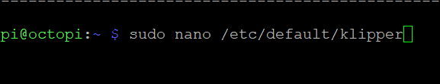

**Change the script so it looks like the following. This points klipper to the printer_config directory that you are about to make.**

*# Configuration for /etc/init.d/klipper*

KLIPPY_USER=pi KLIPPY_EXEC=/home/pi/klippy-env/bin/python KLIPPY_ARGS="/home/pi/klipper/klippy/klippy.py /home/pi/printer_config/printer.cfg -l /tmp/klippy.log -a /tmp/klippy_uds"

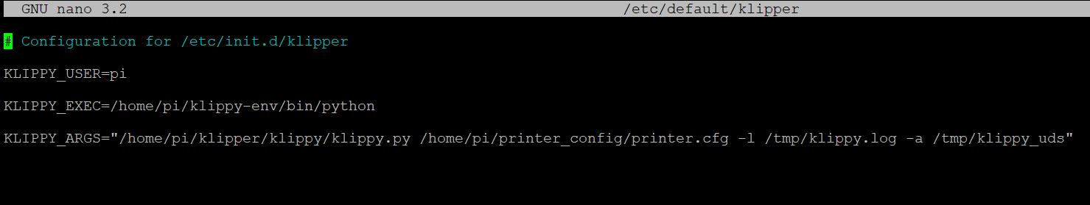

**Once you have done this press Ctrl + x to prompt exit file and then press y to save the changes.**

**Now create a folder called printer_config in /home/pi and move your printer.cfg file to the directory, then move into the newly created printer_config directory:**

cd /home/pi

mkdir printer_config

mv printer.cfg printer_config

cd printer_config

**Now create a file called moonraker.conf in this directory:**

sudo nano /home/pi/printer_config/moonraker.conf

**Copy this text to the file for your basic moonraker config:**

# Sample Moonraker Configuration File

[server]

# Bind server defaults of 0.0.0.0, port 7125

enable_debug_logging: True

[file_manager]

config_path: /home/pi/printer_config

[database]

database_path: ~/.moonraker_database

[authorization]

enabled: True

trusted_clients:

127.0.0.1

force_logins: False

# Enter your client IP here or range here

cors_domains:

# Allow CORS requests for Fluidd

<http://app.fluidd.xyz>

# Enable Octoprint compatibility for Slicer uploads Supports Cura,

# Slic3r, and Slic3r dervivatives (PrusaSlicer, SuperSlicer)

[octoprint_compat]

[update_manager KlipperScreen]

type: git_repo

path: ~/KlipperScreen

origin: <https://github.com/jordanruthe/KlipperScreen.git>

env: ~/.KlipperScreen-env/bin/python

requirements: scripts/KlipperScreen-requirements.txt

install_script: scripts/KlipperScreen-install.sh

**If you need extra config for moonraker then you can read the documentation here:**

<https://moonraker.readthedocs.io/en/latest/configuration/>

**Now we can clone the moonraker git repository with these commands:**

cd

git clone <https://github.com/Arksine/moonraker.git>

**Then run the install with the following command-** (I could only seem to get moonraker working properly by installing it in the printer_config directory. In the /home/pi directory I would get a error message about permissions) :

cd ~/moonraker/scripts ./install-moonraker.sh -f -c /home/pi/printer_config/moonraker.conf

**Now moonraker should be working.**

**Reboot the system for good measures:**

sudo reboot now

**Now we can carry on and install klipperscreen with the following command:**

cd ~/git clone https://github.com/jordanruthe/KlipperScreen.gitcd ~/KlipperScreen./scripts/KlipperScreen-install.sh

**Now we are going to modify some files. Type the following command:**

sudo nano /boot/config.txt

**Scroll to the bottom of the file and add these lines (only add display_rotate if you are wanting to rotate your screen display. Options are from 0-4 from memory. You will need to reboot after the change to make sure it has rotated to where you want it)**

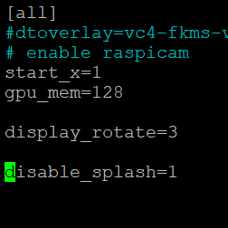

Press ctrl+x and then y to save.

**Then copy/paste this command:**

sudo nano boot/cmdline.txt

**At the end of the line after “rootwait” copy/paste the following:**

splash quiet plymouth.ignore-serial-consoles logo.nologo vt.global_cursor_default=0

**It should look something like this:**

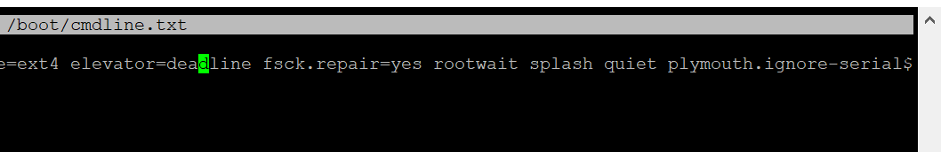

**Now ensure that xinput and xserver and x11 is installed:**

sudo apt-get install libx11-dev libxext-dev libxi-dev x11proto-input-dev

wget <http://github.com/downloads/tias/xinput> … 7.5.tar.gz

sudo apt install xinput

**Then**

sudo apt install xserver-xorg-input-evdev

**If you need to rotate the screen then run the following command to find the name of your screen:**

DISPLAY=0 xinput –-list

**You should see something like this:**

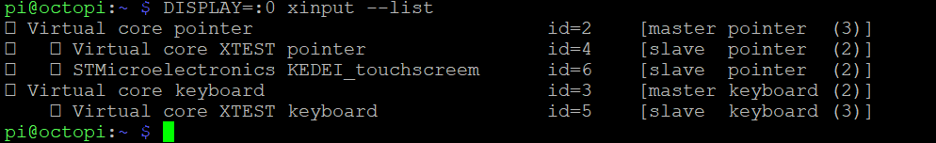

(Notice that my screen has a typo in the name “ STMicroelectronics KEDEI_touchscreem” instead of “touchscreen”........ That held me up for quite some time lol.)

**Now type the following but replace my screens name with the name of your device:**

DISPLAY=0 xinput –list-props “STMicroelectronics KEDEI touchscreem”

**You should see something like this:**

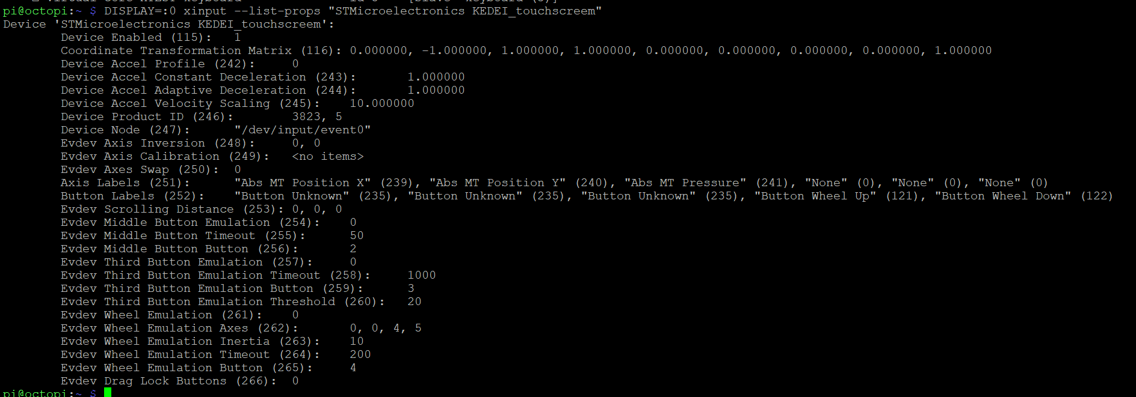

**Take note of the factory coordinate transformation matrix. Now type this command to rotate the matrix (you may need a different matrix combination than mine depending on your screen. Just have a search around for combinations and you will find one eventually):**

DISPLAY=0 xinput set-prop “STMicroelectronics KEDEI_touchscreem” ‘Coordinate Transformation Matrix’ 0 –1 1 1 0 0 0 0 1

**Test the touch matrix to check that it is correct for the screen oreintation.**

**Once satisfied then run the following command and add these lines:**

sudo nano /etc/udev/rules.d/51-touchscreen.rules

**Add the following line, changing your screen name and matrix to suit.**

ACTION=="add", ATTRS{name}== “STMicroelectronics KEDEI_touchscreem”, ENV{LIBINPUT_CALIBRATION_MATRIX}="0 –1 1 1 0 0 0 0 1 "

**Press ctrl+x and then y to save.**

**Also modify this file and add this line:**

sudo nano /etc/rc.local

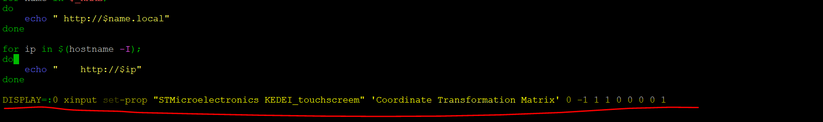

**NOTE:**

#### **Touchscreen Calibration**

Most people don't need to calibrate, but if you do need to calibrate your touchscreen, follow the below steps.

sudo add-apt-repository ppa:tias/xinput-calibrator-ppa

sudo apt-get install xinput_calibrator

Run this command:

DISPLAY=:0 xinput_calibrator --list

It will output something such as:

Device "wch.cn USB2IIC_CTP_CONTROL" id=6

Find the ID of your display and put it in the following command:

DISPLAY=:0 xinput_calibrator -v --device <id from last command>

**Now install omxplayer:**

Sudo apt install omxplayer

**Now you can make your boot screen splash video. I used davinci resolve because to make mine because its free. There are plenty of tutorials on youtube.**

**Next we need to transfer our video to the rpi. Im unsure how to do this via terminal so I used winscp to move the video file to /home/pi (named hevort.mov):**

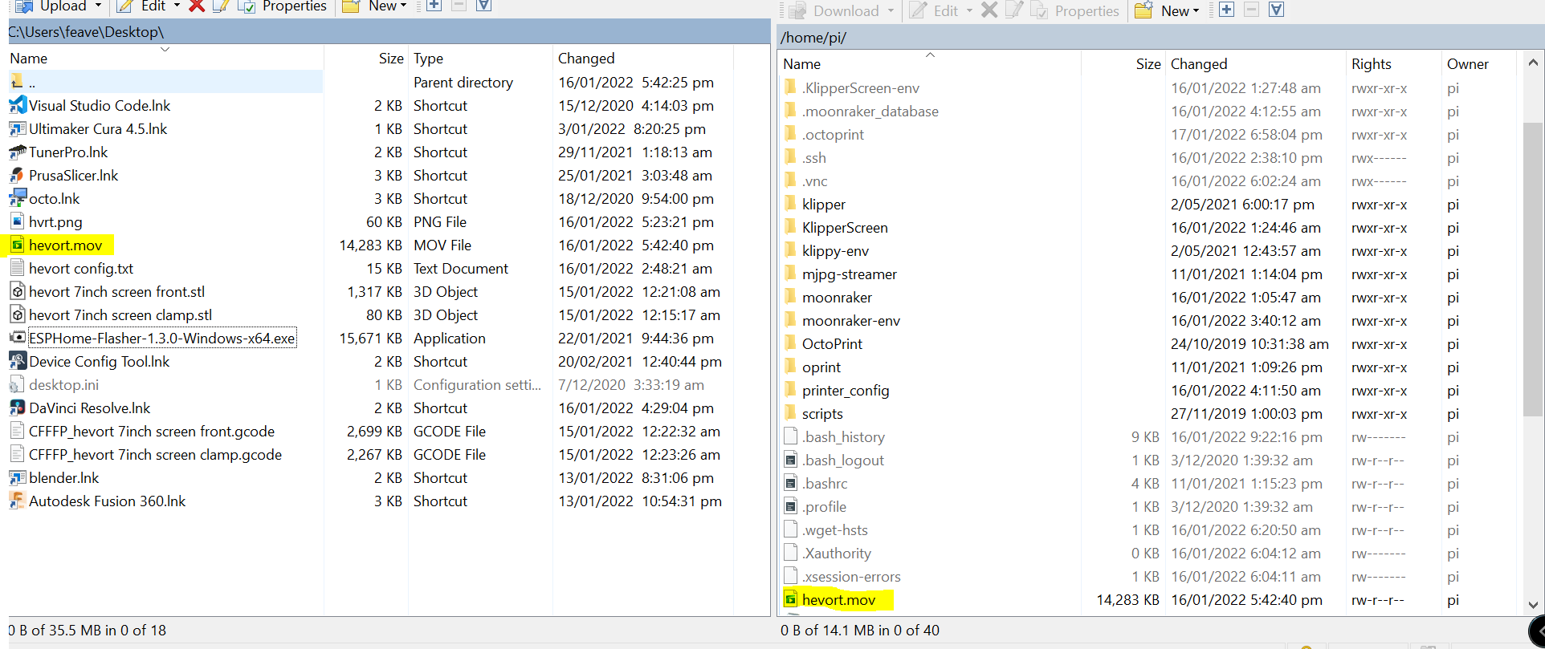

**Now we can confirm the splash screen is working by running this command in the terminal:**

omxplayer hevort.mov

**All going well the splash screen should play. Now we can modify one more file to make the splash screen play on boot:**

sudo nano /etc/rc.local

**Add this line at the bottom of the page before exit0:**

omxplayer /home/pi/hevort.mov &

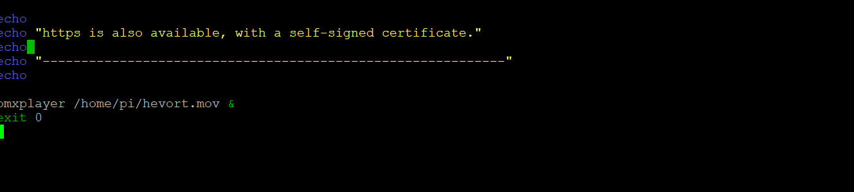

**Ctrl+x and y to save.**

**Congratulations! You should now have a working (maybe rotated) touchscreen with your own custom splash video!!!**

